**Predicting the Likelihood of Health-Related Transportation Issues for Medicare Members Using a Gradient Boosting Tree Approach**

**Humana-Mays Healthcare Analytics Case Competition**

**October 2020**

Humana lists Social Determinants of Health (SDoH) as one of their five points of influence for improving patient health outcomes. Transportation is a key determinant of health, and issues in transportation lead to widespread missed appointments and negative health outcomes for patients. Accurately predicting which Medicare members are most likely to have transportation issues can help health insurance providers design customized solutions for these members. We used data from Winter 2019 from roughly 70,000 Humana members to build a Gradient Boosting Tree model to predict the probability of each member facing health-related transportation issues, achieving an AUC score of 0.747 when testing the model on a validation dataset. In this report, we identify key drivers of transportation issues and develop scalable business solutions for specific segments of Humana members based on this model. These recommendations are designed to improve the overall health outcomes of Humana members by addressing these transportation issues and to increase Humana’s return on investment (ROI).

**Table of Contents**

1. INTRODUCTION

1.1 Background

1.2 The Humana Analytics Competition

1.2.1 The Business Issue

1.2.2 Key Performance Indicators

1. DATA PREPARATION

2.1 Analytical Tools Used

2.2 Exploratory Data Analysis

2.2.1 Understanding Variables

2.2.2 Data Cleaning

2.2.3 Variable Reduction

2.3 Feature Engineering

2.3.1 One-Hot encoding

2.3.2 Supplemental Feature: hosp_per_sq_mi

1. MODELING

3.1 Model Selection

3.2 Model Tuning

3.3 Final Model

3.4 Feature Importance

3.4.1 Top 10 Features: Individual Dependency Analysis

1. FUTURE STEPS - ANALYSIS AND ACTIONABLE INSIGHTS

4.1 Proposed Solutions

4.2 Segmentation and Scalability

4.3 Next Steps

4.3.1 Identifying Geographic Hotspots

4.3.2 Surveying Members

1. CONCLUSION
2. APPENDIX
3. REFERENCES

**1. INTRODUCTION**

**1.1 Background**

According to the Robert Wood Johnson Foundation, “Social Determinants of Health (SDoH) are conditions in the places where people live, learn, work and play (that) affect a wide range of health risks and outcomes. They are the barriers to health upstream from our traditional healthcare system - things like poor education, low income, or lack of transportation, as well as food insecurity and loneliness.”1 Megan Callahan, the Vice President of Health Care at Lyft, also mentioned that “transportation can be one of the most important social determinants of health and also one of the most cost-effective options.”1

In 2019, McKinsey & Company conducted the Consumer Social Determinants of Health Survey. It was found that 53% of respondents were impacted by at least one of these SDoH and that 15% had unmet social needs specifically in transportation.2 Additionally, respondents reporting unmet transportation needs were 2.6x more likely to report multiple ER (emergency room) visits and 2.2x more likely to report an IP (in-patient) visit in a 12-month period.2 Unsurprisingly, 85% of respondents reporting multiple unmet social needs indicated that they would use a social program offered by their health insurance provider.2

According to Humana, patients tend to miss appointments and become non-adherent to treatment plans and medication due to the inability to get to these appointments, related tests and the pharmacy.3 Similarly, the American Hospital Association stated in 2017 that a lack of medical transportation was the leading cause of patient no-shows.3 These missed appointments are associated with increased costs for the patient, disruption of provider-patient relationships, delayed care, and increased emergency room visits.3 The fiscal implications of these trends are clear as well; it is estimated that missed appointments cost the healthcare industry an annual total of $150 billion.3

Based on the variety of negative impacts that these issues have on the general health of the aforementioned patient groups as well as the financial well-being of health care providers, it is optimal for all involved parties that these providers be able to proactively identify which of their patients are most likely to be struggling with health-related transportation issues. More importantly, it is crucial that these providers are able to take steps to address these issues.

**1.2 The Humana Analytics Competition**

**1.2.1 The Business Issue**

Humana’s Bold Goal is to improve the health of the communities in their service. Humana’s two enterprise strategies are to deliver an easy, seamless customer consumer experience and improve health outcomes of members.3

In this report, we discuss the use of Humana’s Medicare member data (as well as supplemental public data from various sources) to predict the likelihood of each member experiencing health-related transportation issues. We examine the specifics of each model that was implemented, the most significant features affecting transportation, and the corresponding business actions that could be taken to address these issues.

**1.2.2 Key Performance Indicators**

We have identified the following key performance indicators to evaluate the business problem:

1. **Health outcomes.** We design solutions around Humana’s Bold Goal to increase patient access to health care and improve health outcomes.
2. **Cost of care.** We ensure that the cost of care for members is affordable.
3. **Scalability of proposed solutions.** We outline steps for scaling these solutions to make them more broadly applicable.
4. **Fiscal implications for Humana.** We develop profitable solutions that improve Humana’s long-term ROI.

**2. Data Preparation**

**2.1 Analytical Tools Used**

All of the following analysis was coded in Python and implemented in Jupyter Notebooks. We used the Pandas and Numpy libraries for our initial data exploration and feature selection, Scikit-learn and Keras to implement and test various machine learning models, and Seaborn and Matplotlib to create visualizations based on our selected model.

**2.2 Exploratory Data Analysis**

**2.2.1 Understanding Variables**

In the training dataset, there were 826 features and 69572 members. Features were categorized primarily into the following groups:

* Medical claims data
* Pharmacy claims data
* Lab claims data
* Demographic/consumer data
* Credit data
* Clinical condition data
* CMS member data

Additionally, each feature fell into one of three classes: categorical data, numeric data, and binary indicators (1 = positive indicator, 0 = negative indicator).

**2.2.2 Data Cleaning**

Many of the features in the dataset contained null values. Simply dropping each member that contained one or more null values was not a feasible solution as 99.78% of the members fit this classification. We instead removed features that contained 70% or more null values and replaced the remaining missing data with the median of the respective column.

**2.2.3 Variable Reduction**

In order to reduce the dimensionality of the dataset, we performed extensive research on each feature provided. We sorted the features into the following categories: behavioral, financial, hospital history, lifestyle, geographic, and medical history. We selected the most important and representative features from each category.

From the behavioral category, we included features most related to mental health. We also included the Medicare segmentation feature, which categorizes members based on their personality type.

From the financial category, we included the features that best summarize a member’s financial status, including the low income indicator and the balance of all mortgage and credit accounts.

From the hospital history category, we included the total number of hospital and physician office visits for each member. Members with a higher number of visits are more likely to have faced some transportation issues compared to those who rarely needed to commute to the hospital or doctor’s office.

The lifestyle and geographic categories consisted of one or two columns each. From the lifestyle category, we included each member’s participation in the Silver Sneakers Senior Exercise Program as an indicator of their general health and independence. For the geographic category, we included the hospitals per square mile for each zip code, which we generated from external data (see 2.3. Feature Engineering).

The medical history category consisted mainly of the betos- and submcc- variable groups. In order to assess the relevance of different medical conditions, we filtered the data in Excel to include only members testing positive for a given condition. We repeated this for each condition and recorded the number and percentage of members from each population that had experienced health-related transportation issues in the past. This helped give us an initial idea of which medical conditions should be included in our analysis.

After reducing the dimensionality and performing one-hot encoding and feature supplementation (see 2.3 Feature Engineering) we move forward with 176 features for further analysis.

**2.3 Feature Engineering**

**2.3.1 One-Hot Encoding**

Machine learning models are inherently mathematical, and a common problem that arises as a result of this is the presence of categorical (nonnumeric) variables. In Humana’s dataset, some examples of these variables included language spoken, sex, and Medicare segmentation. One-hot encoding is the process of translating categorical variables into a series of binary indicators in order to record that same data in a numeric fashion that is more compatible with modeling efforts. For example, a language feature having two categorical entries (ENG, SPA) would be transformed into two separate columns: one binary indicator for members that speak English and another for those that speak Spanish (Figure 1).

A downside of one-hot encoding is the generation of a new feature for every unique value of the corresponding categorical variable; however, the inevitably sparse nature of the resulting binary indicators means that performance issues as a result of this process are uncommon. After extensive variable reduction, Humana’s dataset contained a total of eight categorical variables, which were translated into a total of 59 binary indicators.

| | lang_spoken_cd | | --- | | ENG | | SPA | | ENG | | ENG | | SPA | | | lang_spoken_cd_ENG | lang_spoken_cd_SPA | | --- | --- | | 1 | 0 | | 0 | 1 | | 1 | 0 | | 1 | 0 | | 0 | 1 | |
| --- | --- | --- | --- | --- | --- | --- | --- | --- | --- | --- | --- | --- | --- | --- | --- | --- | --- | --- | --- |

**Figure 1.** Categorical data before and after one-hot encoding.

**2.3.2 Supplemental Feature: hosp_per_sq_mi**

In an effort to best predict the likelihood of a Medicare member experiencing health-related transportation issues, a measure of each member’s general proximity to their corresponding care facility was desired. In order to achieve this, two supplemental datasets were incorporated: the U.S. Census Gazetteer Files4—which contain information regarding the area of all U.S. zip codes—and a government-maintained list of all hospitals registered with Medicare and their corresponding addresses.5 First, a feature that counted the number of Medicare hospitals in each member’s zip code was generated. The area of each zip code was then incorporated. These two features were used to generate the final hosp_per_sq_mi feature, a measure of Medicare hospital density in the immediate vicinity of each member.

**3. MODELING**

**3.1 Model Selection**

We examined five different binary classification algorithms: Support Vector Machines (SVM), Logistic Regression, Random Forests, Neural Networks, and Gradient Boosting Trees. We evaluated each model by calculating probabilities for each Medicare member and then calculating AUC scores using labeled training data.

Each algorithm was tested with a baseline set of parameters before undergoing hyperparameter tuning. The SVM and Neural Network models encountered a variety of performance issues while also achieving substantially lower AUC scores. The Logistic Regression, Random Forest, and Gradient Boosting Tree models were thus selected for fine tuning.

**3.2 Model Tuning**

For each model, a randomized search across a wide range of parameters was performed. Optimal parameters from the randomized search were then used to devise a more granular set of potential parameter values. The final parameters were then determined via four-fold cross validation. Each model was run ten times with identical random states used to further partition Humana’s data into training and testing sets for model tuning. The optimized hyperparameters and AUC scores for each model are listed in Figure 2.

| Model | Tuned Hyperparameters | Average AUC Score |
| --- | --- | --- |
| **Random Forest** | n_estimators = 800  min_samples_split = 5  min_samples_leaf = 1  max_features = ‘sqrt’  max_depth = 110  bootstrap = False | 0.730 |
| **Logistic Regression** | test size = 0.1  random state = 7  n_samples = 1000  n_classes = 2 | 0.732 |
| **Gradient Boosting Tree** | learning_rate = 0.005  max_depth = 5  max_features = 13  min_samples_split = 1200  min_samples_leaf = 50  n_estimators = 1500  subsample = 0.8 | 0.747 |

**Figure 2.** Tuned hyperparameters and AUC scores for each model.

**3.3 Final Model**

The Gradient Boosting Tree model was identified as optimal and was thus selected for use on the holdout data. Further tuning led to an optimal ROC curve (Figure 3) with an AUC score of 0.75 when tested with the validation set.

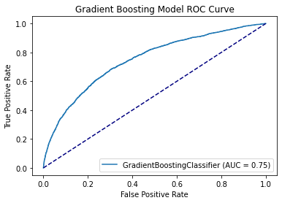

**Figure 3.** ROC curve for the tuned Gradient Boosting Tree model.

**3.4 Feature Importance**

In order to develop insights from the model output, it is important to understand which of the included features have the greatest impact on the target variable. To accomplish this, the 20 most important features (assessed by the Gradient Boosting Tree model) were plotted (Figure 4).

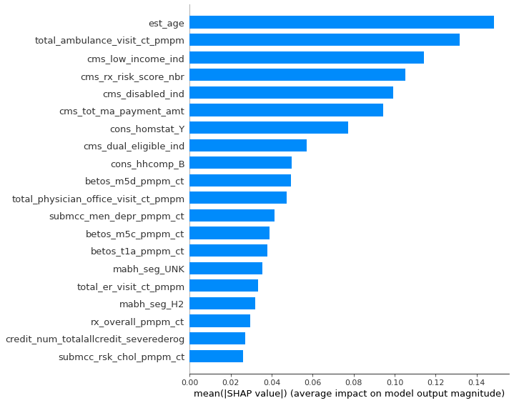

**Figure 4:** Top 20 most important features in the tuned Gradient Boosting Tree model.

The above features were grouped into broader categories: physical/health, financial, hospital visit history, home status, and age. Since these categories are substantially represented in the top ten features, our following analysis focuses on those features. The definitions for the top twenty features can be found in the Appendix. We list the top ten here for reference:

**est_age** - Member age calculated using est_bday, relative to score/index date

**total_ambulance_visit_ct_pmpm** - Total number of ambulance visits per month

**cms_low_income_ind** - Low income subsidy indicator from CMS

**cms_rx_risk_score_nbr -** CMS Medicare Rx Risk Score

**cms_disabled_ind** - Disability indicator

**cms_tot_ma_payment_amt** - Total Medicare Advantage payment amount

**cons_homstat_Y** - Homeowner indicator

**cms_dual_eligible_ind** - Dual eligibility indicator (eligible for both Medicare and Medicaid)

**cons_hhcomp_B** - Indicates if member lives with spouse and no children present

**betos_m5d_pmpm_ct** - Number of visits to a specialist per month

The SHAP Python library was used to gain a better understanding of each of these features. A feature having a higher SHAP value has a greater influence on the overall output of the target variable. The SHAP value of a feature also varies with the relative value of that feature (Figure 5). For example, est_age has a higher SHAP value for younger members, implying that they can be more easily classified by the model (as younger members are much less likely to experience transportation issues).

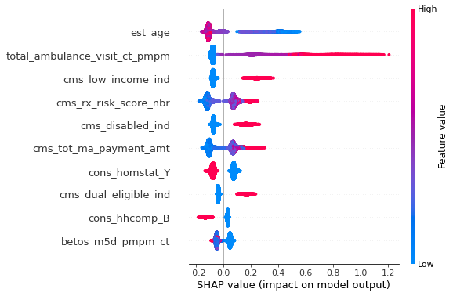

**Figure 5.** SHAP value as a function of relative feature value for the 10 most important features.

**3.4.1 Top 10 Features: Individual Dependency Analysis**

Age:

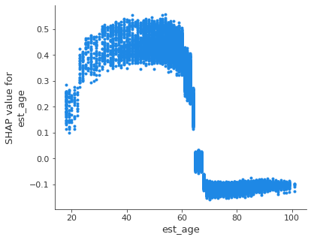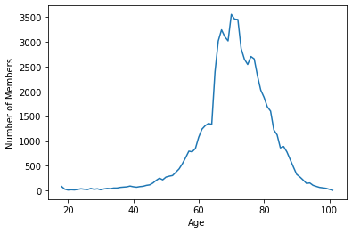

**Figure 6.** SHAP value as a function of est_age feature (left) and age distribution of dataset (right).

The high SHAP value of the est_age feature when it is roughly 60 or less indicates that younger members are more easily classified by the model. Per our model predictions, they are generally classified as a 0 for transportation issues, presumably due to their independence and general mobility. To investigate this further, we plotted the distribution of ages in the dataset (Figure 6). From this plot, we see that the vast majority of Humana’s members are above the age of 60. Since they represent a much higher percentage of the dataset, these members cannot be as easily classified; thus, the model continues to explore other features.

Physical/Health:

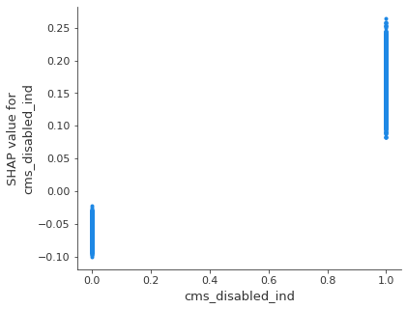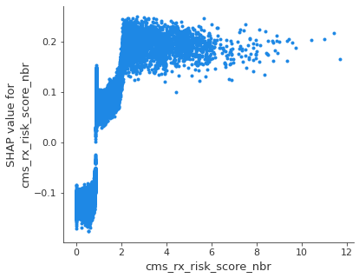

**Figure 7.** SHAP value as a function of cms_disabled_ind (left) and as a function of cms_rx_risk_score_nbr (right).

These graphs detail how the cms_disabled_ind and cms_rx_risk_score_nbr features generally have a greater effect on model output when they have higher values (Figure 7). This is likely due to members with disabilities having difficulty utilizing public transportation or driving themselves to appointments without assistance.

Financial:

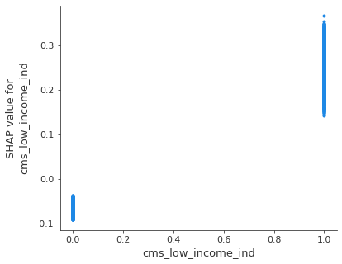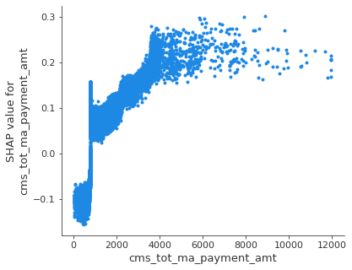

**Figure 8.** SHAP value as a function of cms_low_income_ind (left) and as a function of cms_tot_ma_payment_amt (right).

The first graph above shows that the cms_low_income_ind feature exhibits a higher SHAP score when it is classified as 1 (Figure 8), while the second graph shows that the cms_tot_ma_payment_amt feature has a higher SHAP score when it has a value greater than or equal to 4000 (Figure 8). Upon further investigation, we found that low income individuals are more likely to face transportation issues, while this is less often the case for high-paying Medicare Advantage members. Lower income individuals are likely to have trouble paying for transportation and might not own a vehicle, and these individuals also face a lack of Medicare Advantage benefits that would allow them to bypass transportation issues.

Hospital visit history:

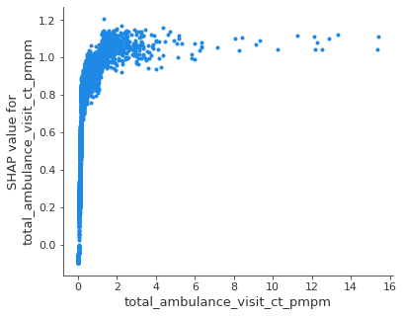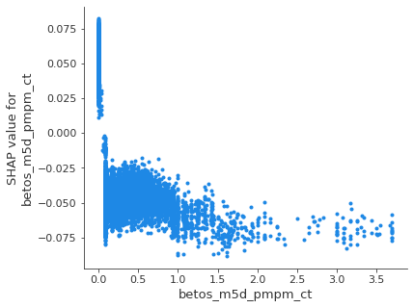

**Figure 9.** SHAP value as a function of total_ambulance_visit_ct_pmpm (left) and as a function of betos_m5d_pmpm_ct (right).

The first graph shows a high SHAP value for the total_ambulance_visit_ct_pmpm feature when it has a value of 1.5 or higher (Figure 9). Presumably, members who frequently use ambulance services tend to have more health problems in general, making them more likely to experience transportation issues. The second graph shows that the betos_m5d_pmpm_ct feature exhibits a high SHAP value when it has a value of 0, presumably because members who cannot see a specialist as often are more likely to be those experiencing transportation issues (Figure 9).

Home status:

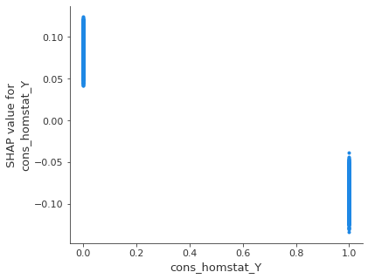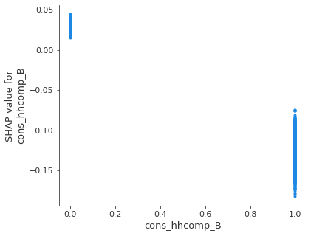

**Figure 10.** SHAP value as a function of cms_homstat_Y (left) and as a function of cons_hhcomp_B (right).

The first graph plots SHAP value by homeowner status indicator (Figure 10). This feature has a higher SHAP value when it is classified as 0, and members who fit this classification generally report a 1 for transportation issues—likely because they are low-income individuals. The second graph plots SHAP value as a function of cons_hhcomp_B, which indicates whether a member lives with only their spouse. This feature has a higher SHAP score when its value is 0, presumably because members like these don’t have anyone to help them with transportation.

Miscellaneous - Medicare (age) /Medicaid (income) dual eligibility:

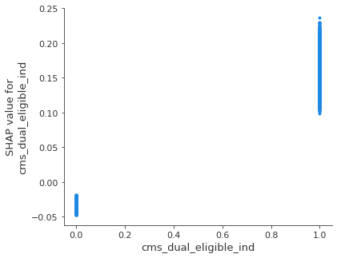

**Figure 11.** SHAP value as a function of cms_dual_eligible_ind.

Medicare/Medicaid dual eligibility is for members who are both senior citizens and low-income. This feature has a higher SHAP value when it is classified as 1, likely since dually eligible members are more likely to face transportation issues as a result of their low-income status (Figure 11).

**4. FUTURE STEPS - ANALYSIS AND ACTIONABLE INSIGHTS**

Based on the results of our analysis, we propose a class of four different solutions for Humana to implement: virtual appointments, partnerships with walk-in retail clinics and urgent care centers, non-emergency medical transportation (NEMT) programs, and in-house care. Below, we outline past efforts at implementing these solutions along with the feasibility of each solution. We also outline the extent to which they could benefit patients, insurers, and care providers. It is important to note that Humana and several other insurers and care providers already offer some of these services, and that much of the value in our analysis comes in the form of a rigorous and scalable methodology for identifying which solution best suits each member.

**4.1 Proposed Solutions**

**Virtual Appointments**

Currently, Humana offers telemedicine in many of its plans. We believe that expanding the use of telemedicine can reduce transportation issues, specifically for individuals with chronic illnesses and/or lowered mobility. We recommend expanding Humana’s telemedicine service to high-risk individuals if they are not already included, and advertising the service to these members specifically. We especially recommend taking advantage of telemedicine for older individuals that live with someone who can help them navigate the online platform.

Recent technological advances along with the demands introduced by the COVID-19 pandemic have given rise to an abundance of research into the benefits of virtual care. In addition to being effective in preventing the spread of infectious diseases like COVID-19, virtual care is fiscally beneficial. The average telehealth visit costs $79, while the average office visit costs $146. Therefore, by leveraging telehealth, Humana can lower the costs of covering medical services that their members require.6 We recommend that Humana continue to leverage virtual care post-pandemic.

One concern with virtual care is that the decreased cost for patients can lead to unnecessary use.6 Once the COVID-19 pandemic ends and it is safe for members to visit the doctor in-person, we recommend that Humana prioritizes virtual service for groups of patients facing more severe chronic illnesses and mobility issues. For healthier members, we recommend increasing the price of telemedicine appointments. This will deter these members from overusing the system and resolve transportation issues for members with high medical risk and low mobility.

**Partner with Retail Clinics and Urgent Care Centers**

Another step we propose is the expansion of Humana’s partnerships with care providers in the form of retail clinics and urgent care centers. In addition to Humana and other insurers’ experience in this field making it an established practice7, recent increases in the scope of care of these facilities ensures quality of care for patients.8 Retail clinics offer competitive treatment for low-acuity issues that they specialize in at rates that are substantially lower than physician’s offices.9 Thus, it is feasible that Humana could offer plans with lower rates than their current plans centered around hospital-based care in a way that increases their profit margin. These lower rates would also allow for a decrease in member costs and an increase in members’ ability to access the care they need. The ability of retail clinics to host a substantial amount of patients also addresses concerns regarding the scalability of this initiative; a 2017 analysis found that retail clinics serve an average of 9,000 patients annually.10

**NEMT (Non-Emergency Medical Transportation)**

Humana already provides NEMT to a subset of their members, so our main goal is to devise an expansion plan that will help Humana increase their ROI. A 2018 study that tested six diseases for patients that have “sufficient monthly treatment volumes” showed that NEMT results in a total positive ROI of $480 million annually for every 30,000 Medicaid beneficiaries.11 The study also highlights the difference in ROI based on disease, where the treatment of chronic diseases generally leads to a better ROI. For example, dialysis for kidney disease and wound care for diabetes resulted in a positive ROI while treatment for substance abuse generally resulted in a negative ROI.11

Therefore, we suggest that Humana categorizes members by different types of diseases and selects those that require more extensive monthly treatment, which correlates with a lower overall medical fee.11 Humana can offer unlimited NEMT for members with diseases that are associated with a positive ROI, and for those with diseases that are less economically efficient to treat, we propose an alternative structure in which insurance premiums are higher or the extent of NEMT use is limited. By implementing this solution, Humana will enhance the ROI of their NEMT program while resolving transportation issues for its beneficiaries who are chronically ill and/or disabled (Figure 12).

| **Payment Solutions Based on Customer Persona**  (cases may vary by disease type) | | | |
| --- | --- | --- | --- |
| Treatment frequency | 3 - 6 treatments per month | 6 - 11 treatments per month | 11+ treatments per month |
| Potential ROI | Negative | Neutral | Positive |
| Solution (insurance plan to implement or retain) | High-cost plan with unlimited NEMT or  general plan with limited NEMT counts | Retain general plan with unlimited NEMT | Retain general plan with unlimited NEMT |

**Figure 12.** Recommended NEMT protocol and insurance plans based on characteristics of member illnesses.

**In-House Care**

We determined that disabled members and those with high CMS Risk Scores would benefit from in-house medical care. We prioritize members who are above the age of 60 and live by themselves or only with their partner.

According to Harvard Health, all Medicare Advantage members are covered for in-home medical appointments, depending on their health conditions.16 In the past ten years, the number of in-home medical appointments has doubled. 16 In addition to increasing medical access for individuals with chronic health conditions, in-home appointments help foster a provider-patient relationship and allow the provider to have a better understanding of the patient’s living situation.16

Currently, Humana offers in-home support from care managers who answer care-related questions. We propose an addition to Humana’s Special Needs Medicare Advantage plan that includes in-home appointments with medical specialists that are certified to conduct check-ups and administer treatment. Members that are eligible for the program will be over the age of 60, disabled or chronically ill, and live by themselves or only with their partner. Another possibility is a discounted enrollment plan for low-income eligible individuals, which would come at a low cost to Humana since this population comprises only 3% of the dataset.The fiscal benefits of this possibility, however, are relatively uncertain and should be investigated further.

**4.2 Segmentation and Scalability**

As mentioned, Humana and other health insurance companies and care providers already offer some form of the solutions mentioned above. The benefits of our analysis thus come in the form of a rigorous, widely-applicable method of identifying which solutions are compatible with members predicted to be experiencing health-related transportation issues.

We have included the following logic tree to illustrate the concept of funneling members into each of the four solution groups (Figure 13). Threshold values are determined by the analysis of individual features and their relationships with the target variable in section 3.4.1. The tree diagram highlights that there is not a one-size-fits-all method for resolving transportation issues. For members experiencing issues that do not fall into one of the solution classes based on our model, we recommend following up with a survey that would allow them to rank their preferences based on which solution would work best for their situation.

The methodical and objective nature of this solution tree also provides a convenient degree of scalability for segmenting large numbers of members. This logic could feasibly be implemented in code and extended to more features and separate datasets with varying features.

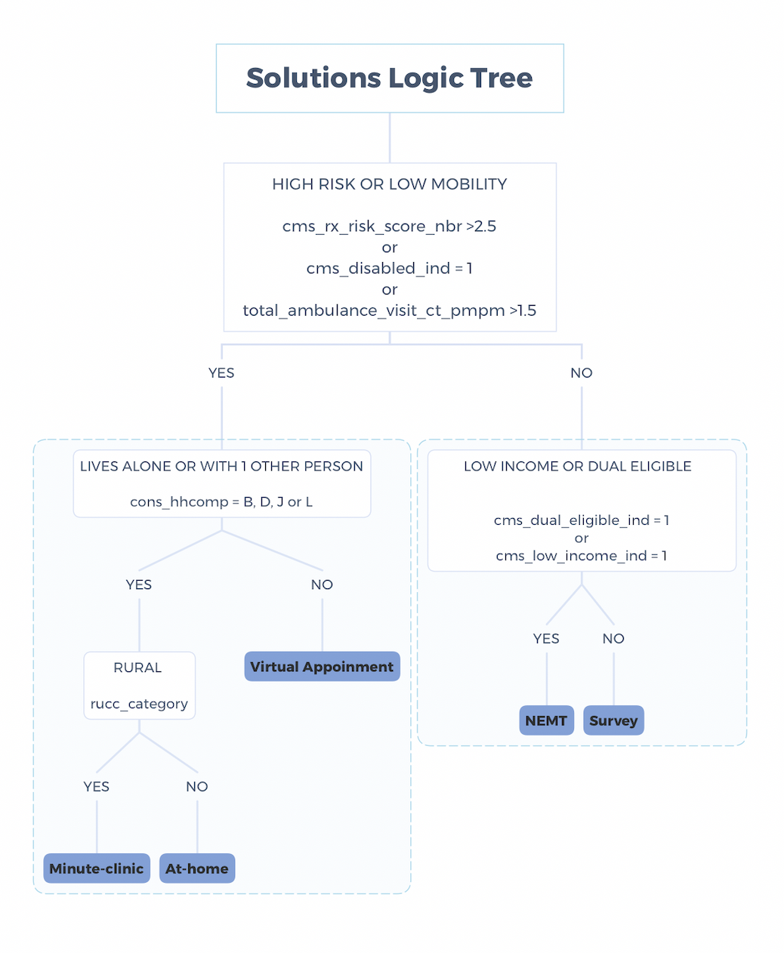

**Figure 13.** Solutions Logic Tree used to determine solutions on a member-by-member basis.

**4.3 Next Steps**

**4.3.1 Identifying Geographic Hotspots**

After classifying members based on the solutions with which they are compatible, we propose a method of targeted solution implementation that would allow geographic “hotspots” to be identified. By identifying members of the same solution class in similar regions, Humana would be able to optimize the locations in which each of the proposed solutions could be rolled out. For example, it would be in Humana’s best interest to roll out in-house care initiatives in areas with dense populations of members matching this solution, allowing individual specialists to service the maximum number of patients possible, keeping costs low. Similar methods could be used to determine how to best expand NEMT programs and how to determine where to implement new partnerships with retail clinics and urgent care centers. Our implementation of this hotspot identification was restricted by a lack of highly specific geographic data and the relatively sparse nature of this geographic data in the dataset—we had access only to zip code information, and roughly two thirds of members had no zip code value at all. The availability of more granular geographic data in a more exhaustive dataset would provide an even more promising means to move forward on the aforementioned solutions.

**4.3.2 Surveying Members**

As a follow-up to the above analysis, we recommend sending out a survey to members that experience transportation issues. This survey would inform them of the new proposed solutions and ask them to rank their preferences for what might help them with transportation while also potentially obtaining some of the aforementioned granular geographic data. With this information, we can iterate on feedback from members to create a more robust segmentation model.

**5. CONCLUSION**

In predicting which of Humana’s Medicare members were most likely to be experiencing health-related transportation issues, we filtered over 826 features down to 176 features for use in our machine learning models, ultimately determining that the Gradient Boosting Tree model, with an AUC score of 0.75, could predict transportation issues most accurately. By identifying individuals with transportation issues and noting key drivers of these outcomes, we generated business proposals such as virtual appointments, retail clinic and urgent care center partnerships, NEMT programs, and in-house care. Additionally, we generated a logic tree to help Humana segment customers for the purpose of applying different business strategies and using geographic data to optimize these strategies. For future considerations, Humana may start to collect feedback from members to iterate on this process and further refine its practice.

**6. APPENDIX**

| **Variable Name** | **Variable Description** |
| --- | --- |
| **est_age** | Member age |
| **total_ambulance_visit_ct_pmpm** | Total number of ambulance visits per month |
| **cms_low_income_ind** | Low income subsidy indicator from CMS |
| **cms_rx_risk_score_nbr** | CMS Medicare Rx Risk Score |
| **cms_disabled_ind** | Disability indicator |
| **cms_tot_ma_payment_amt** | Total Medicare Advantage payment amount |
| **cons_homstat_Y** | Homeowner indicator |
| **cms_dual_eligible_ind** | Eligibility for both Medicare and Medicaid |
| **cons_hhcomp_B** | Indicates if member lives only with partner |
| **betos_m5d_pmpm_ct** | Number of visits to a specialist per month |
| **total_physician_office_visit_ct_pmpm** | Total number of physician visits per month |
| **submcc_men_depr_pmpm_ct** | Count of depression logical claims in a month |
| **betos_m5c_pmpm_ct** | Number of ophthalmology visits per month |
| **betos_t1a_pmpm_ct** | Number of venipuncture lab tests per month |
| **mabh_seg** | Medicare Segmentation |
| **total_er_visit_ct_pmpm** | Total number of ER visits per month |
| **mabh_seg_H2** | Indicates member is auto-pilot participator |
| **rx_overall_pmpm_ct** | Count of prescriptions per month |
| **credit_num_totalallcredit_severederog** | Number of all severe derogatory accounts |
| **submcc_risk_chol_pmpm_ct** | Number of hyperlipidemia claims per month |

**7. REFERENCES**

1. Robert Wood Johnson Foundation. (n.d.). *Population Health | Humana | Social Determinants of Health*. Humana. Retrieved October 4, 2020 <https://populationhealth.humana.com/social-determinants-of-health/>

2. Coe, E. H. (2020, March 1). *Insights from McKinsey’s Consumer Social Determinants of Health Survey*. McKinsey & Company. <https://www.mckinsey.com/industries/healthcare-systems-and-services/our-insights/insights-from-the-mckinsey-2019-consumer-social-determinants-of-health-survey?reload>

3. Humana, & Franklin, S. F. (2019, June). *Transportation Issue Biref*. Humana Population Health. <https://populationhealth.humana.com/wp-content/uploads/2019/08/BG_Transportation-Issue-Brief_1Q2019_EXTERNAL.pdf>

4. US Census Bureau. (2019, August 6). *Gazetteer Files*. The United States Census Bureau. <https://www.census.gov/geographies/reference-files/time-series/geo/gazetteer-files.html>

*5. Find and compare information about Hospitals | Hospital Compare*. (n.d.). Medicare. Retrieved September 28, 2020, from <https://www.medicare.gov/hospitalcompare/search.html>

6. Ibarra, A. B. (2017, March 7). *Are Virtual Doctor Visits Really Cost-Effective? Not So Much, Study Says*. Kaiser Health News. <https://khn.org/news/are-virtual-doctor-visits-really-cost-effective-not-so-much-study-says/>

7. *Humana and Walgreens to Open Additional In-store Partners in Primary Care Centers | Walgreens Newsroom*. (2019, July 30). Walgreens Newsroom. <https://news.walgreens.com/press-releases/humana-and-walgreens-to-open-additional-in-store-partners-in-primary-care-centers.htm>

8. Robin M. Weinick, Rachel M. Burns and Ateev Mehrotra Many Emergency Department Visits Could Be Managed At Urgent Care Centers And Retail Clinics Health Affairs, 29, no.9 (2010):1630-1636 doi: 10.1377/hlthaff.2009.0748 <https://www.healthaffairs.org/doi/full/10.1377/hlthaff.2009.0748>

9. Francis, J. (2015, November 12). *Number of U.S. Retail Health Clinics Will Surpass 2,800 by 2017, Accenture Forecasts*. Accenture, from <https://newsroom.accenture.com/news/number-of-us-retail-health-clinics-will-surpass-2800-by-2017-accenture-forecasts.htm>

10. Mehrotra, A. M., Liu, H. L., Adams, J. A., Wang, M. W., Lave, J. L., Thygeson, N. T., Solberg, L. S., & McGlynn, E. M. (2009, September 1). *Comparing Costs and Quality of Care at Retail Clinics With That of Other Medical Settings for 3 Common Illnesses*. ACP Journals. <https://www.acpjournals.org/action/cookieAbsent>

11. Adelberg, M. A., Salber, P. S., Pruisner, T. P., Cohen, M. C., & Dobosenski, A. D. (n.d.). *Non-Emergency Medical Transportation: Findings from a Return on Investment Study*. Medical Transportation Access Coalition. Retrieved October 5, 2020, from <https://mtaccoalition.org/wp-content/uploads/2018/07/NEMT-ROI-Methodology-Paper.pdf>

12. Centers For Medicare & Medicaid Services. (2016, April). *Fact Sheet | Let Medicaid Give You a Ride*. <https://www.cms.gov/Medicare-Medicaid-Coordination/Fraud-Prevention/Medicaid-Integrity-Education/Downloads/nemt-factsheet.pdf>

13. HealthPayerIntelligence. (2019, February 7). *Lyft Expands Work with BCBS, Humana Medicare Advantage Plans*.

<https://healthpayerintelligence.com/news/lyft-expands-work-with-bcbs-humana-medicare-advantage-plans>

14. BusinessWire. (2018, October 9). *Humana’s 2019 Medicare Health Plans Emphasize Choice, Affordability and Convenience to Care for the Whole Person*. Business Wire A Berkshire Hathaway Company. [https://www.businesswire.com/news/home/20181009005787/en/Humana’s-2019-Medicare-Health-Plans-Emphasize-Choice-Affordability-and-Convenience-to-Care-for-the-Whole-Person](https://www.businesswire.com/news/home/20181009005787/en/Humana%E2%80%99s-2019-Medicare-Health-Plans-Emphasize-Choice-Affordability-and-Convenience-to-Care-for-the-Whole-Person)

15. Humana. (n.d.). *Does Medicare cover transportation services?* Retrieved October 5, 2020， from <https://mtaccoalition.org/wp-content/uploads/2018/07/NEMT-ROI-Methodology-Paper.pdf>

16. Harvard Health Publishing. (n.d.). *The doctor will see you now, in your home*. Harvard Health. Retrieved October 5, 2020, from <https://www.health.harvard.edu/staying-healthy/the-doctor-will-see-you-now-in-your-home>